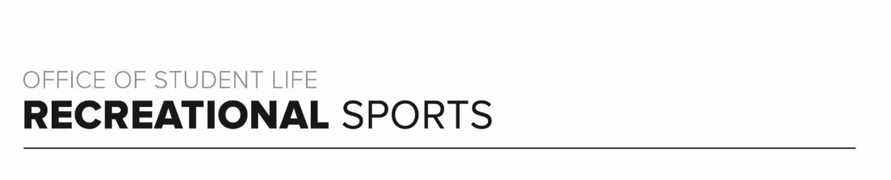

BUCKEYE NAME GAME WORKOUT
Find the letters that spell your first, middle (optional) and last name and complete the exercise and reps listed next to it for fun, full body workout!!!

A- 12 Burpees
B- 25 Jumping Jacks
C- 10 Squats
D- 20 Speed Skaters
E- 12 Burpees
F- 10 Jump Squats
G- 10 Push-Ups H- 25 High Knees I- 12 Burpees
J- 25 Crunches
K- 20 Lunges
L- 25 Bicycle Crunches
M- 1 Minute Plank
N – 10 Tricep Push-Ups
O – 12 Burpees
P- 10 Sumo Squats
Q- 20 Plank Shoulder Taps
R- 20 Glute Bridges
S- 15 Plank Up/Downs
T- 20 Jump Squats
U – 12 Burpees
V – 15 V-Ups
W – 1 Minute Plank
X – 20 Sit -Ups
Y- 20 Speed Skaters
Z- 25 Jumping Jacks

