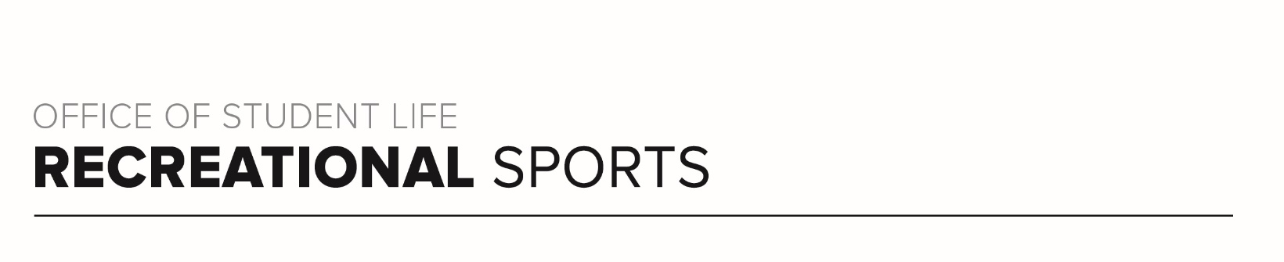
Brutus 1 Workout

Workout Focus:
Total body

Equipment Needed:
Dumbbells

Warm Up: 5 minutes
3-4-minute walk, jog or bike (or jog in place/jumping jacks)
10 body weight squats
10 body weight step back lunges
10 Inchworms (with push-up)

SET 1
Complete series of exercises below for two rounds total. Rest for 7-10 seconds between exercises and 45-60 seconds between rounds. Add one or two dumbbells to increase intensity.

Squat + Knee Drive (50 seconds)
Squat Pulse (20 seconds)
Right Leg Lunge (50 seconds)
Lunge Pulse (20 seconds)
Squat Walks (50 seconds)
Right Leg Tap Backs (20 seconds)
Left Leg Lunge (50 seconds)
Lunge Pulse (20 seconds)
Squat Walks (50 seconds)
Left Leg Tap Backs (20 seconds)
Burner Set (20 seconds each)
- Sumo Squat Pulse
- Right Lunge Pop
- Sumo Squat Pulse
- Left Lunge Pop
- Sumo Squat Hold

ROUND 2
Complete series of exercises plus burner set below for two rounds total. Rest for 7-10 seconds between exercises and 45-60 seconds between rounds.

Push-Up (50 seconds)
Mountain Climbers (20 seconds)
Bent Over Row (50 seconds)
Right Side Standing Oblique Crunch (20 seconds)
Bicep Curl (50 seconds)
Left Side Standing Oblique Crunch (20 seconds)
Tricep Overhead Extension (50 seconds)
Right Side Oblique V-Ups (20 seconds)
Tricep Push-Up (50 seconds)
Left Side Oblique V-Ups (20 seconds)

Burner Set (20 seconds each)
- Push-Up Pulse
- Right Side Bicycle Pulse
- Tricep Push-Up Pulse
- Left Side Bicycle Pulse
- Plank Hold

ROUND 3
Do each exercise for 30 seconds for 2 rounds total.

- Right Leg Donkey Kicks
- Right Side Clamshell
- Right Leg Glute Bridge
- Leg Lowers
- Scissor Kicks
- Left Leg Donkey Kicks
- Left Side Clamshell
- Left Leg Glute Bridge
- Leg Lowers
- Scissor Kicks

