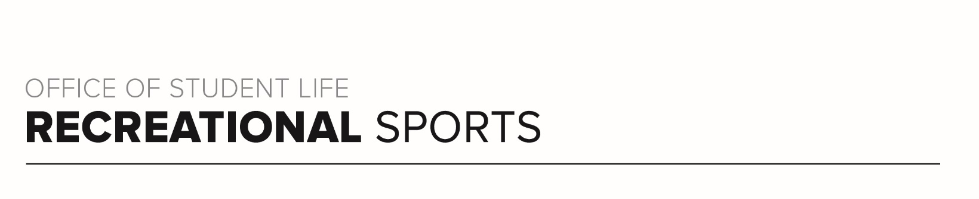
Brutus Workout (#2)

Workout Focus:
Total body

Equipment Needed:
Dumbbells

Warm Up: 5 minutes
3-4-minute walk, jog or bike (or jog in place/jumping jacks)
10 body weight squats
10 body weight step back lunges
10 good mornings
5 Inchworms (with push-up)
25 jumping jacks

ROUND 1
Complete each set of exercises below 3 times total with 60 seconds rest between sets.

- Dumbbells Squats (15 reps)
Jump Squats (30 seconds)
*Recover (30 seconds)

- Plank Push-up (12 reps)
Plank Jacks (30 seconds)
*Recover (30 seconds)

- Dumbbell Alternating Step Back Lunges (15 reps)
Cycled Split-Squat Jump (30 seconds)
*Recover (30 seconds)

- Bicep Curl to Shoulder Press (12 reps)
Burpee with Push-up (8 reps)
*Recover (30 seconds)

ROUND 2
Complete each set of exercises below 3 times total with 60 seconds rest between sets.

- Dumbbell Bulgarian Split Lunge (10 reps each leg)
Dumbbell Glute Bridge (10 reps)
Jump Squats (30 seconds)
*Recover (30 seconds)

- Chest Press (10 reps)
Single-Arm Row (10 reps each arm)
Plank Jacks (30 seconds)
*Recover (30 seconds)

- Lateral Lunges (10 each leg reps)
Squat hold (30 seconds)
Cycled Split-Squat Jump (30 seconds)
*Recover (30 seconds)

- Overhead Triceps extension (12 reps)
Hammer Curl (12 reps)
Burpee with Push-up (8 reps)
*Recover (30 seconds)

ROUND 3
Do each core exercise for 25 reps x 2 sets.

- Vertical Toe Touch
- Scissor kicks
- Hip Raise
- Front Plank (30 seconds)

