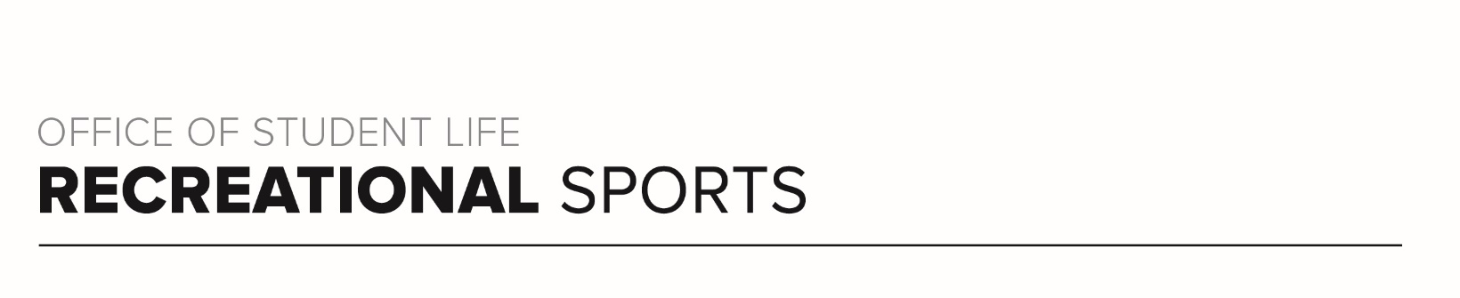
Brutus Workout (#3)

Workout Focus:
Total body

Equipment Needed:
Dumbbells

Warm Up: 5 minutes
3-4-minute walk, jog or bike (or jog in place/jumping jacks)
10 body weight squats
10 body weight step back lunges
10 good mornings
5 Inchworms (with push-up)

ROUND 1
Complete each set of exercises below 4 times total with 30-60 seconds rest between sets.

- Dumbbells Squats (40 seconds)
Jump Squats (20 seconds)
Alternating Reverse Lunge (40 seconds)
Cycled Split-Squat Jump (20 seconds)

- Bent Over Row (40 seconds)
Seal Jacks (20 seconds)
Push-Ups (40 seconds)
Plank Jacks (20 seconds)

- Sumo Squat (40 seconds)
Squat + Side Kick (20 seconds)
Alternating Curtsey Lunges (40 seconds)
Speed Skaters (20 seconds)

- Bicep Curl (40 seconds)
High Row (20 seconds)
Tricep Kickback (40 seconds)
Lateral Raise (20 seconds)

ROUND 3
Complete 50 reps total of each exercise below. You can do exercises in any order and for any amount at one time.

Sit-Ups
Mountain Climbers
Russian Twists
Toe Touches
Burpees

ROUND 3
Complete each set of exercises below 4 times total with 30-60 seconds rest between sets.

- Overhead Press (40 seconds)
Right Split Squat (20 seconds)
Narrow Press (40 seconds)
Left Split Squat (20 seconds)

- Reverse Fly (40 seconds)
Deadlift (20 seconds)
Wide Bicep Curl (40 seconds)
Single Leg Deadlift (20 seconds)

- Chest Fly (40 seconds)
Glute Bridge (20 seconds)
Chest Press (40 seconds)
Single Leg Glute Bridge (20 seconds)

- Pull Overs (40 seconds)
Scissor Kicks (20 seconds)
Tricep Extension (40 seconds)
Criss-Cross Kicks (20 seconds)

ROUND 4
Complete 25 reps total of each exercise below. You can do exercises in any order and for any amount at one time.

Sit-Ups
Mountain Climbers
Russian Twists
Toe Touches
Burpees

