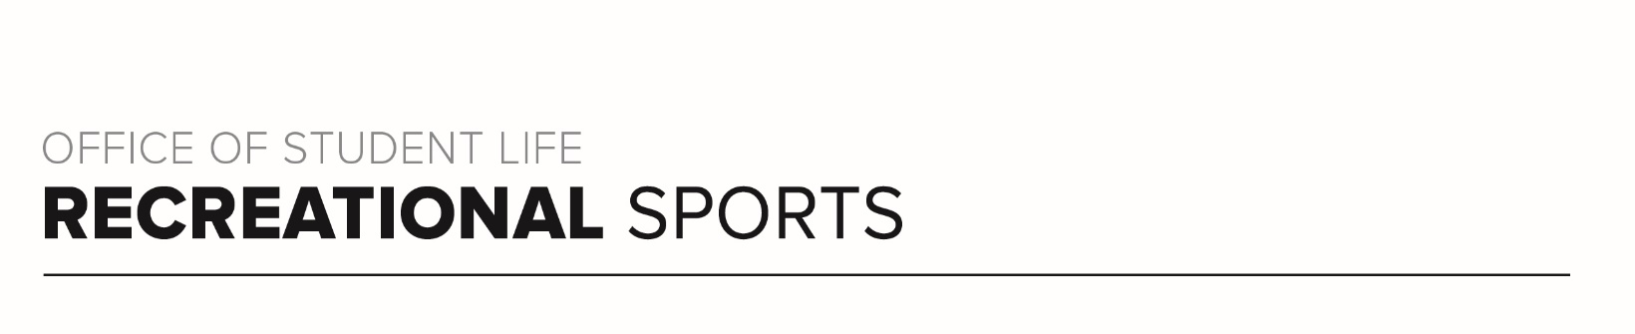
Buckeye 1 Workout

Workout Focus:
Total body

Equipment Needed:
Dumbbells, resistance band, plyo box or step

Warm Up: 5 minutes
3-4-minute walk, jog or bike (or jog in place/jumping jacks)
10 body weight squats
10 body weight step back lunges
10 good mornings
5 Inchworms (with push-up)
25 jumping jacks

SET 1 (Lower Body)
Do exercises 1-6 in a row and complete 3 rounds total. Rest 15-30 seconds between exercises and 60-90 seconds between rounds.

- Dumbbells Squat to Press (15 reps)
- Dumbbell Step Ups (16 reps)
- Box Jumps or Drop Squat (10 reps)
- Resistance Band Adductors (15 reps)
- Dumbbell Glute Bridge (15 reps)
- Resistance Band Lunge (16 reps)

SET 2 (Upper Body)
Do exercises 1-6 in a row and complete 3 rounds total. Rest 15-30 seconds between exercises and 60-90 seconds between rounds.

- Decline Push-ups (10 reps)
- Dips (15 reps)
- Dumbbell Bicep curl (15 reps)
- Resistance Band Front Raise (10 reps)
- Dumbbell Bent over Fly (10 reps)
- Single Arm Row with Tricep kickback (8 reps per arm)

SET 3 (Tabata Cardio)
Do each exercise for 20 seconds, completing as many reps as possible. Rest 10 seconds between exercises. Complete 2 rounds total.

- Jumping Jacks
- Box jump, or step ups
- Drop Squats
- Dumbbell alternating reserve lunge with shoulder press

SET 4 (Core)
Do each core exercise for 25 reps, 2 rounds total. Rest 15-20 seconds between exercises.

- Weighted sit up
- Front Plank (30 seconds)
- Oblique v-up
- Oblique v-up
- Front Plank (30 seconds)

