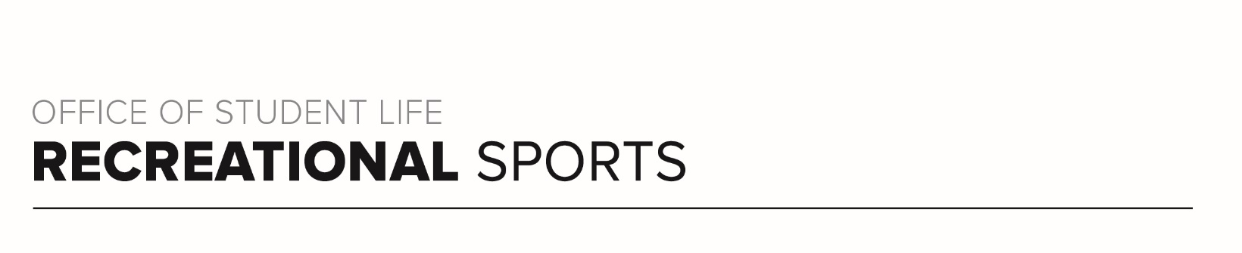
Buckeye Workout (#2)

Workout Focus:
Total body

Equipment Needed:
Dumbbells

Warm Up: 5 minutes
3-4-minute walk, jog or bike (or jog in place/jumping jacks)
10 body weight squats
10 body weight step back lunges
10 good mornings
5 Inchworms (with push-up)
25 jumping jacks

ROUND 1
Grab a set of medium to heavy weights and complete each set of exercises below 3 times total with 30-60 seconds rest between sets.

- Squat (30 seconds)
Squat to Overhead Press (30 seconds)
Overhead Press (30 seconds)
*Mountain Climbers (20 reps)

- Deadlift (30 seconds)
Deadlift to Bent Over Row (30 seconds)
Bent Over Row (30 seconds)
*Plank Jacks (20 reps)

- Alternating Step Back Lunge (30 seconds)
Alternating Lunge to Bicep Curl (30 seconds)
Bicep Curl (30 seconds)
*Sit-Ups (20 reps)

- Sumo Squat (30 seconds)
Sumo Squat to High Row (30 seconds)
High Row (30 seconds)
*Bicycle Crunches

ROUND 2
Complete push-up/cardio challenge below as quickly as you can.

10 Push-Ups / 20 High Knees
9 Push-Ups / 5 Burpees
8 Push-Ups / 15 High Knees
7 Push-Ups / 10 Burpees
6 Push-Ups / 10 High Knees
5 Push-Ups / 20 Burpees

ROUND 3
Grab one heavy weight and complete each set of exercises below 2 times total (once each side) with 30-60 seconds rest between sets.

- Lateral Lunge (60 seconds)
Overhead Tricep Extension (60 seconds)
*Russian Twists (20 reps)

Repeat other side

- Single Leg Deadlift (60 seconds)
Single Arm Curl to Press (60 seconds)
* Standing Oblique Crunch (20 reps)

Repeat other side

- Single Leg Glute Bridge (60 seconds)
Weighted Pullovers (60 seconds)
* Weighted Crunch (20 reps)

Repeat other side

ROUND 4
Complete each movement for 20 seconds each, resting 10-15 seconds in between.

Right Side Plank with Reach Through
Front Plank with Alternating Leg Lifts
Left Side Plank with Reach Through
Front Plank with Alternating Arm Lifts
Hollow Rocks
Reverse Plank

Repeat round once more for additional challenge!

