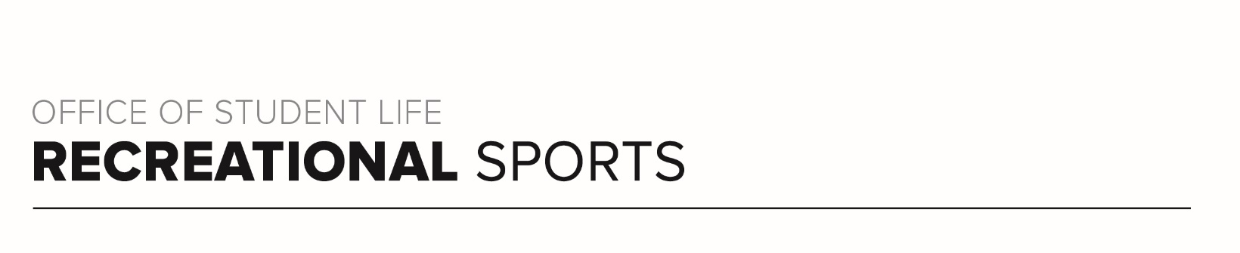
Buckeye Workout (#3)

Workout Focus:
Total body

Equipment Needed:
Dumbbells and Loop Bands

Warm Up: 5 minutes
3-4-minute walk, jog or bike (or jog in place/jumping jacks)
10 body weight squats
10 body weight step back lunges
10 good mornings
5 Inchworms (with push-up)

ROUND 1
Grab a set of medium to heavy weights and place the loop band around your thighs, right above your knees. Complete each set of exercises below 2 times total.

- Squat to Narrow Press (60 seconds)
Bicep Curl (45 seconds)
Right Leg Tap Backs (30 seconds)
Left Leg Tap Backs (30 seconds)
Wide Bicep Curl (45 seconds)
Deadlift to High Row (60 seconds)

- Jump or Drop Squats (20 reps)
Plank Jacks (15 reps)
Banded Burpees (10 reps)
- Right Donkey Kick (60 seconds)
Right Side Clamshells (45 seconds)
Right Side V-Ups (30 seconds)
Left Side V-Ups (30 seconds)
Left Side Clamshells (45 seconds)
Left Donkey Kick (60 seconds)

- Bent Over Row (20 reps)
Push-Ups (15 reps)
Plank Up Downs (10 reps)

ROUND 2
Complete cardio/core challenge below as quickly as you can.

10 Russian Twists / 20 High Knees
9 Sit-Ups / 18 Speed Skaters
8 Russian Twists / 16 High Knees
7 Sit-Ups / 14 Speed Skaters
6 Russian Twists / 12 High Knees
5 Sit-Ups / 10 Speed Skaters

ROUND 3
Grab one heavy or two medium/light weights and place band around thighs, right above knees. Do exercises below for 60 seconds each, completing 2x total.

- Lateral Leg Lift (60 seconds)
Overhead Tricep Extension (60 seconds)
Leg Lift + Tricep Extension (60 seconds)

- Squat Walks (60 seconds)
Arnold Press (60 seconds)
Squat Walks + Arnold Press (60 seconds reps)

- Banded Glute Bridge (60 seconds)
Chest Press (60 seconds)
Bridge + Chest Press (60 seconds)

*Bonus Challenge: add a 15-30 second hold or pulse to each movement at the end of each set (ex. 15 second lateral leg lift hold + 15 second tricep pulse after set 1)

ROUND 4
Complete each movement for 45 seconds each, resting 10-15 seconds in between.

Bicycle Crunches
Leg Lowers
Reverse Crunch
Side Plank Right
Side Plank Left
Swimmers

Repeat round once more for additional challenge!

