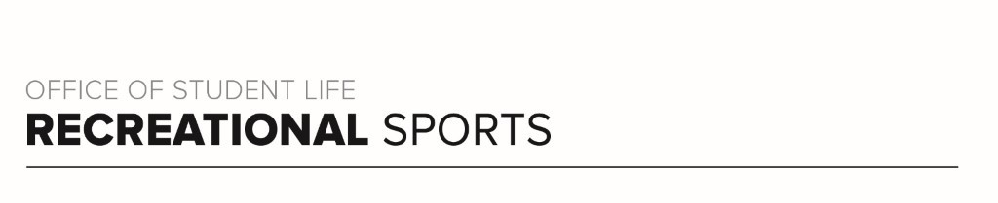

Buckeye 4 Workout
By Catherine R.

Workout Focus:
Total Body

Equipment Needed:
Dumbbells

Warm Up: About 5 minutes
20 Jumping jacks
10 Body Weight Squats
10 Reverse Lunges
5 Inchworms with Push Up
Repeat 3x

SET 1: 12 MINUTES
Grab two medium to heavy dumbbells. Complete the circuit 3x for 40 seconds of work, 20 seconds of rest. Take a 30 seconds rest after each set (all four moves once).

Alternating Curtsy Lunge to Sumo Squat
Squats (+ add pulse at the bottom)
Bent-Over Row
Alternating Lateral Lunge + Overhead Press

Cardio Burst TABATA: 4 MINUTES
Complete these two moves four times through, alternating between the two moves for 20 seconds of high intensity work followed by 10 seconds of rest. 4 minutes of work.

High Knees
Squat to Oblique Crunch

SET 2: 9 MINUTES
Grab two medium dumbbells. Complete the circuit 3x for 30 seconds of work, 15 seconds of rest. Take a 30 seconds rest after each set (all four moves once).

Push Ups
Kneeling Bicep Curl + Arnold Press
Plank + Hip dip
Glute Bridge

Cardio Burst TABATA: 4 MINUTES
Complete these two moves four times through, alternating between the two moves for 20 seconds of high intensity work followed by 10 seconds of rest. 4 minutes of work.

Bicycles
Mountain climbers

SET 3: AS LONG AS YOU NEED!
Run through each move from the two previous circuits 12 reps each exercise, then 10 reps each exercise, finishing with 8 reps each exercise. Complete with as little rest as able.

Alternating Curtsy Lunge to Sumo Squat
Squats (+ add pulse at the bottom)
Bent-Over Row
Alternating Lateral Lunge + Overhead Press
Push Ups
Kneeling Bicep Curl + Arnold Press
Plank + Hip dip
Glute Bridge

Repeat the round once more with 6 reps each exercise for an additional challenge!

