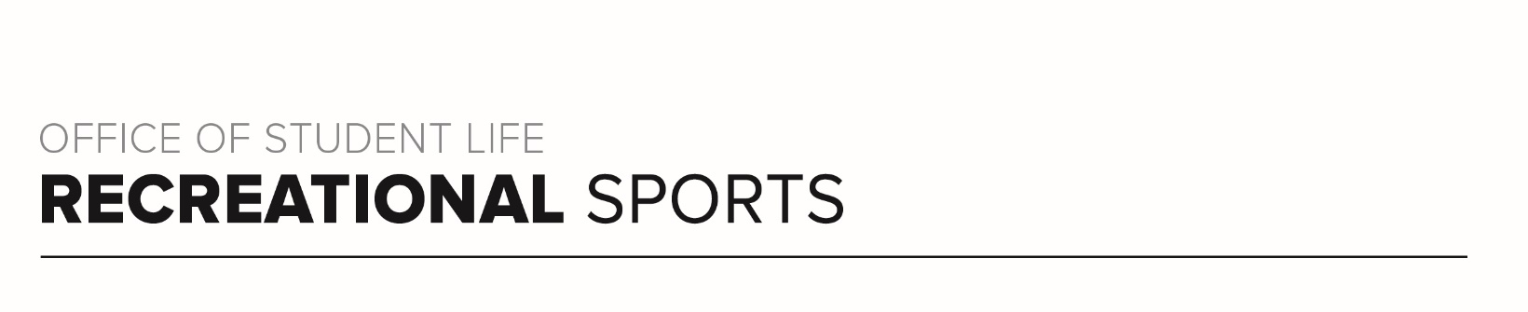
Before You Participate

By voluntarily participating in this exercise program offered by The Ohio State University’s Department of Recreational Sports, you are agreeing that you fully understand the dangers of participation in a program of strenuous physical activity and that you understand that you may be injured as a result of your participation. The Ohio State University strongly recommends that you consult with your physician or other medical-professional prior to beginning this exercise program. By participating, you acknowledge that you are knowingly assuming all risk of injury to yourself, and agree to release and discharge The Ohio State University and its board and employees (collectively, “Ohio State”) from any and all claims or causes of action, known or unknown, including those arising out of Ohio State’s negligence.

