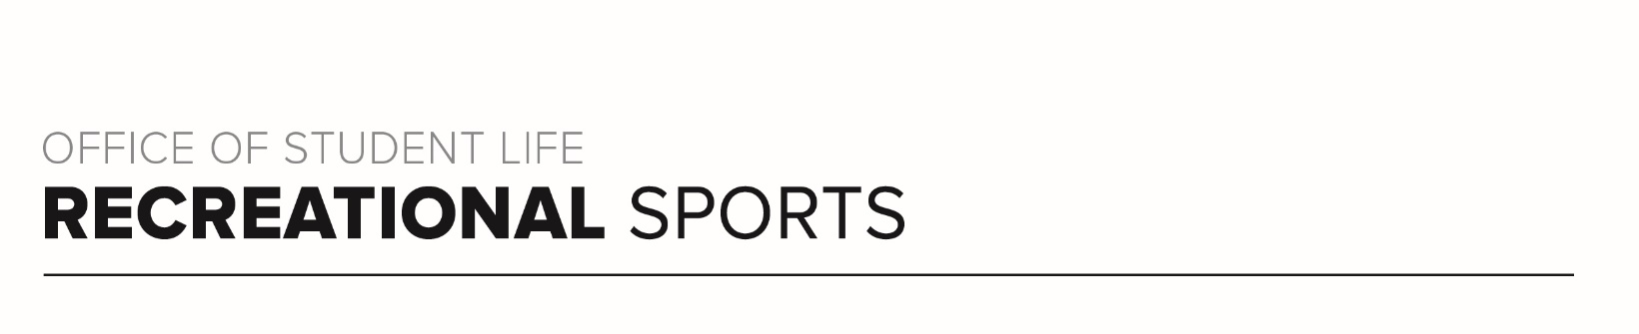
Gray Workout
Workout Focus:
Upper Body
Obliques

Equipment Needed:
Dumbbells

Warm Up: 5 minutes
3-4-minute walk, jog or bike (or jog in place/jumping jacks)
Upper Body Stretches (arms, shoulders, upper back and triceps)

SET 1
In this set there are (2) 40 second rounds followed by a rep based push-up round. The reps will start at 20 and drop 5 reps each round, ending with 5.

Hammer Curls
Bent Over Rows
20 reps – Push-Up

Regular Bicep Curls
Renegade Rows
15 reps – Push-Up

Overhead Shoulder Press
Upright/High Rows
10 reps – Push-Up

Overhead Tricep Extensions
Arnold Shoulder Press
5 reps – Push-Up

SET 2
Set the clock for 30 seconds. Recovery can be 5-6 seconds. Position will switch often, so be prepared to move quickly. Repeat the set 2x….around 8 total minutes.

Slow Cross Body Mountain Climbers (Opposite knee to opposite elbow)
Left Side Plank Hold
Bicycle Crunch
Right Side Plank Hold
Wide Slow Mountain Climbers (Knee to same side elbow)

Set 3
Set 3 will go back to the arms but works exercises with lighter weights. Similar to set 1, you will have (2) 40 second rounds and then weave in a push-up, this time a tricep push-up for reps.

Reverse Fly
Lateral Shoulder Raise
5 reps Tricep Push-Up

Tricep Kickbacks
Front Shoulder Raise
10 reps Tricep Push-Up

Bent Over Wide Row
L Shoulder Raise (One arm lateral and arm front, alternating)
15 reps Tricep Push-Up

Straight Arm Tricep Kickbacks
Butterfly Shoulder Press
20 reps Tricep Push-Up

Set 4
This final set will work the triceps and core. This is the last set in class. Timer should be set for 30 seconds with quick transitions between movements. Repeat 2x.

Tricep Skullcrushers
Alternating Heel Taps
Scissors Kicks
Full Sit Up
Russian Twist

