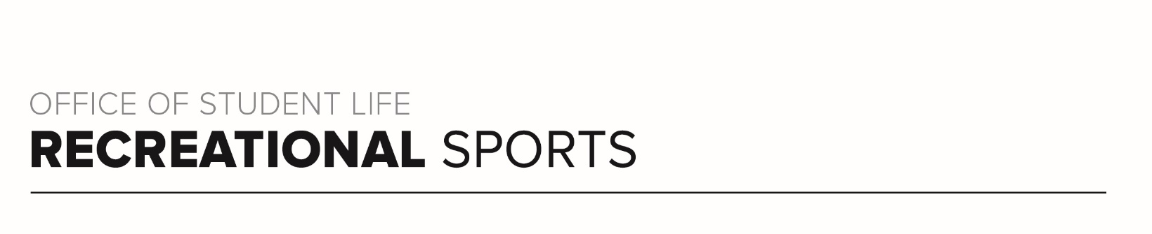
Gray Workout (#3)

Workout Focus:
Upper Body
Core

Equipment Needed:
Dumbbells

Warm Up: 5 minutes
3-4-minute walk, jog or bike (or jog in place/jumping jacks)
Upper Body Stretches
Including the arms, shoulders, upper back and triceps

SET 1
In this set there are (5) rep rounds that will work up and down the pyramid. Complete all exercises during the first round, take a 45 second break, then move onto the next round.

Round 1 – 12 Reps Each Exercise
Round 2 – 10 Reps Each Exercise
Round 3 – 8 Reps Each Exercise
Round 4 – 10 Reps Each Exercise
Round 5 – 12 Reps Each Exercise

Overhead Shoulder Press
Regular Bicep Curl
Upright Row
Renegade Row
Push Ups

SET 2
Set the clock for 30 seconds. Recovery can be 5-6 seconds. Start in plank position and transition to laying on your back. Repeat the set 2x.

Plank + Knee Taps
Bear Hold
Ab Roll Up (Full Sit Up)
Right Leg Lift
Leg Leg Lift

SET 3
Set 3 will go back to the arms but works exercises with lighter weights. Like set 1, you will have (5) rep rounds that will work up and down the pyramid. Complete all exercises during the first round, take a 45 second break, then move onto the next round.

Round 1 – 10 Reps Each Exercise
Round 2 – 8 Reps Each Exercise
Round 3 – 6 Reps Each Exercise
Round 4 – 8 Reps Each Exercise
Round 5 – 10 Reps Each Exercise

Bicep Curl to Overhead Press
Reverse Fly
Single Arm Triceps Kickback
Lateral Shoulder Raise
Serving Biceps

SET 4
This final set will work the triceps and obliques. This is the last set in class. Timer should be set for 30 seconds with quick transitions between movements. Repeat 2x.

Right Side Plank
Triceps Dips
Left Side Plank
Triceps Push Ups
Cross Body Mountain Climbers (Knee towards opposite elbow)

