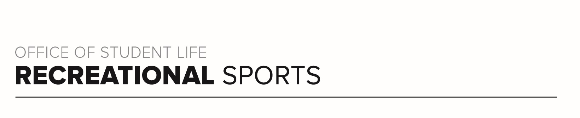
Gray Workout (#2)

Workout Focus:
Upper Body
Core/Obliques

Equipment Needed:
Dumbbells

Warm Up: 5 minutes
3-4-minute walk, jog or bike (or jog in place/jumping jacks)
Upper Body Stretches
Including the arms, shoulders, upper back and triceps

ARM SET 1
In set 1 you will work a push-up series in a ladder series. Standing at the top of your mat, inchworm down and complete 2 push-ups, inchworm back up. Add 2 reps each time building to 12 reps.

Inchworm Down
2 Reps – Push-up
Inchworm Up

Inchworm Down
4 Reps – Push-up
Inchworm Up

Repeat for 6 reps, 8 reps, 10 reps and 12 reps.

ARM SET 2
For Set 2, grab some dumbbells and complete quick 30 second rounds of shoulder press variations. In between each of these rounds you will grab a bench or coffee table and complete 20 reps of a tricep dip. You will complete this round 2x total.

30 seconds – Overhead Shoulder Press
20 reps – Tricep Dips

30 seconds – Alternating Overhead Shoulders Press
20 reps – Tricep Dips

30 seconds – Neutral Grip (Palms Facing) Shoulder Press
20 reps – Tricep Dips

30 seconds – Arnold Shoulder Press
20 reps – Tricep Dips

Repeat 1x

CORE SET 1
In this core set, start in tabletop position. Rounds are 40 seconds long.

Bird Dog (Right Arm, Left Leg)
Bird Dog (Left Arm, Right Leg)
Left Side Forearm Plank Hold
Forearm Plank Hold
Right Side Forearm Plank Hold
Repeat 1x

ARM SET 3
This set will incorporate shoulder exercise that require lighter weights. Each round is 40 seconds. After every 2 or 3 rounds complete 10 tricep push-ups.

Lateral Shoulder Raise
Upright Row
Standing Rear Delt Row (Wide Row)
10 Reps – Tricep Push-up

Front Shoulder Raise
90 Degree Deltoid Raise
10 Reps Tricep Push-ups

Repeat 1x

CORE SET 2
This final set will work the core. This is the last set in class. Timer should be set for 45 seconds with quick transitions between movements. Repeat 2x.

Full Sit Up
Russian Twist
Leg Drops
Scissor Kicks

