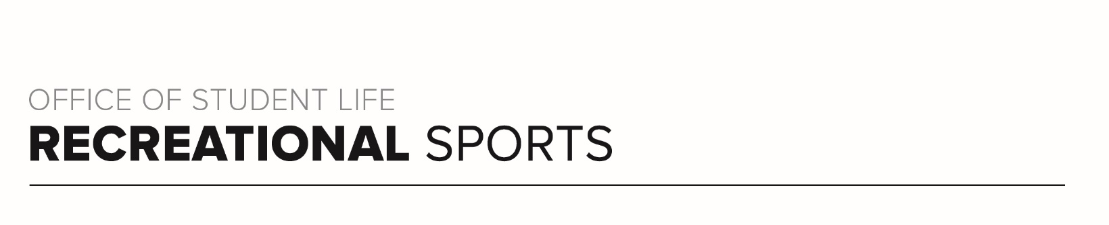
Scarlet 1 Workout

Workout Focus:
Lower Body
Core

Equipment Needed:
Dumbbells

Warm Up: 5 minutes
3-4-minute walk, jog or bike (or jog in place/jumping jacks)
10 body weight squats
10 body weight step back lunges
10 good mornings
25 jumping jacks

SET 1
Add a lower body exercise each round and then start to peel the rounds back on round 3. You can use a single heavy dumbbell or 2, (participants choice). 60 second rounds with 7-8 seconds recovery in between.

Goblet Squats
Alternating Step Back Lunges

Goblet Squats
Alternating Step Back Lunges
Sumo Squats

Alternating Step Back Lunges
Sumo Squats
Alternating Lateral Lunges

Sumo Squats
Alternating Lateral Lunges
Deadlifts

Alternating Lateral Lunges
Deadlifts

Set 2
Set the clock for 30 seconds. Recovery can be 5-6 seconds. 8 total rounds of core, all in plank position. Modified plank on the knees when needed. Should be repeated 1x (16 rounds for 8 total working minutes).

High Plank Hold
Plank Shoulder Taps
Plank Walk Outs
Forearm Plank Hold
Left Side Forearm Plank Hold
Plank Up/Downs (High Plank to Low Plank)
Right Side Forearm Plank Hold
Plank Walk Outs

Set 3
60 second rounds on the legs like in Set 1. Weaving in rep rounds of the exercises in Set 1. Once you complete the reps, move to the next 60 second movement. You will then repeat the 60 second round moves 1 more time for 30 seconds.

Alternating Curtsy Lunges
20 reps Goblet Squats

Calf Raises
20 reps Sumo Squats

Right Leg Single Leg Deadlift
20 reps Alternating Lateral Lunges (10R/10L)

Left Leg Single Leg Deadlift
20 Deadlifts

30 second round (GO HEAVY)
Alternating Curtsy Lunges
Calf Raises
Right Leg Single Leg Deadlift
Left Leg Single Leg Deadlift

Set 4
Final set for this workout working the core and the glutes one final time. All rounds should be 30 seconds on with 5-6 seconds in between. Start laying on the back. Repeat 2x.

Crunches
Glute Bridges
Scissor Kicks
Right Leg Single Leg Glute Bridge
Bicycle Crunch
Left Leg Single Leg Glute Bridge

