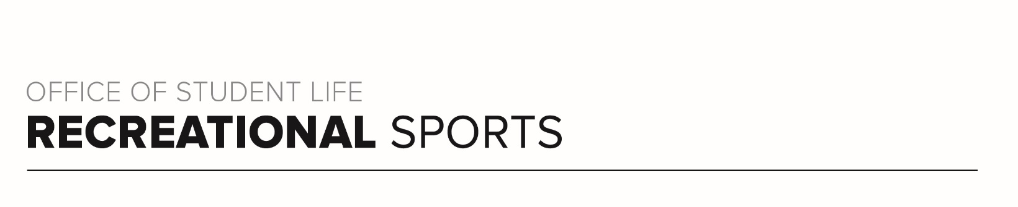
Scarlet Workout (#3)

Workout Focus:
Lower Body
Core

Equipment Needed:
Dumbbells

Warm Up: 5 minutes
3-4-minute walk, jog or bike (or jog in place/jumping jacks)
10 body weight squats
10 body weight step back lunges
10 good mornings
25 jumping jacks

SET 1
Legs: 60-45-30 Round. You will do each exercise for 60 seconds. Repeat for 45 seconds and finally for 30 seconds. Your goal each round is go up in weight or maintain what you start with. In between the time changes, you will do 10 Pop Squats or Jump Squats. Use heavy dumbbells!

60 seconds each
Goblet Squats
Alternating Reverse Lunges
Alternating Single Leg RDLs
*10 Pop Squats or Jump Squats (Body Weight)

45 seconds each
Goblet Squats
Alternating Reverse Lunges
Alternating Single Leg RDLs
*10 Pop Squats or Jump Squats (Body Weight)

30 seconds each
Goblet Squats
Alternating Reverse Lunges
Alternating Single Leg RDLs
*10 Pop Squats or Jump Squats (Body Weight)

CORE
All exercises are in plank position. Complete exercises below for 30 seconds each, 2 rounds total.

30 seconds each
Full Plank Hold (on palms)
Slow Mountain Climbers (Right Knee to Right Elbow Only)
Plank Hip Dips
Slow Mountain Climbers (Left Knee to Left Elbow Only)
Plank Jacks (Go for speed!)

SET 2
Legs: This is like set 1 however you will work 1 leg at a time and each leg will be completed for 60 seconds and then 45 seconds. 10 squat jacks in between each round for 40 total squat jacks and a little heart rate increase.

60 seconds each
Right Leg Lateral Lunge
Right Leg Lateral Leg Lift
Right Leg Curtsy Lunge
*10 Squat Jacks

60 seconds each
Left Leg Lateral Lunge
Left Leg Lateral Leg Lift
Left Leg Curtsy Lunge
*10 Squat Jacks

45 seconds each
Right Leg Lateral Lunge
Right Leg Lateral Leg Lift
Right Leg Curtsy Lunge
*10 Squat Jacks

45 seconds each
Left Leg Lateral Lunge
Left Leg Lateral Leg Lift
Left Leg Curtsy Lunge
*10 Squat Jacks

CORE 2
Lay on your back. Place hands under glutes for extra support if needed. Complete exercises below for 30 seconds each, 2 rounds total.

30 seconds each
Leg Lifts or Tabletop Heel Drops
Flutter Kicks
Side to Side Heel Taps
Reverse Crunch

