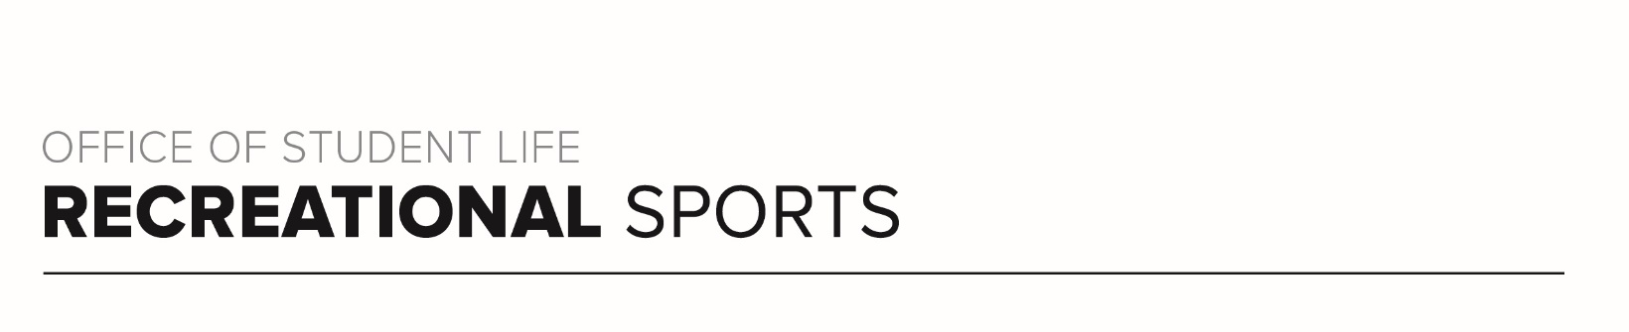
Scarlet Workout (#4)

Workout focus​:
Lower body
Core

Equipment Needed​:
Mini Loop Resistance Band (medium to heavy)

Warm-up​: 6 minutes
Do each exercise for 30 seconds each and repeat 3 times
Jumping jacks
Bodyweight squat
Reverse lunges (alternate legs)
Plank walk-out (optional push-up)

SET 1
Legs​: 50-40-30 round. Do each exercise for 50 seconds, then repeat for 40s and then repeat a final time for 30 seconds. Place your band above your knees. Your goal each round is to increase resistance or maintain what you start with. In between each round (each time change), you will do 10 drop-squats or jump squats.

50-40-30 seconds each
- Lateral squat walk (3 steps right, 3 steps back to the left)
- Squat with a lateral raise
- Single-leg lateral lunge with a balance at the top (right leg)
- Single-leg lateral lunge with a balance at the top (left leg)
- 10 drop-squats or jump squats

CORE
All exercises performed in plank position. Complete exercises below for 30 seconds each, 2 rounds total. Resistance band optional.

30 seconds each
- Bodyweight Plank (palms or forearms)
- Plank with toe tap
- Rocking Plank (forearms)
- Plank with leg lift
- Plank jacks (go for speed!)

SET 2
Thighs and glutes​: Perform all four exercises lying on the left side (working right leg) first, then repeat all exercises on the other side. Complete exercises below for 30 seconds each, 1-2 rounds total (either complete each move once or twice per side). Medium to heavy resistance.

30 seconds each on each side
- Side lying leg lifts
- Side lying inner leg lifts
- Clamshell
- Inverted clamshell (knees drop to ground, feet elevated, open and close legs from this position)

CORE
Lay on your back. Place hands under glutes for extra support if needed. Complete exercises below for 30 seconds each, 2 rounds total. Can be done with resistance.

30 seconds each
- Butterfly kicks
- Scissor Kicks
- Leg Lowers
- Reverse Crunch
- Leg lower with Reverse Crunch

SET 3
Glutes​: Perform all exercises on hands and knees (can drop down to forearms if wrists are uncomfortable) and begin on the right side, then repeat all three moves on the left). Complete exercises below for 30 seconds each, 1-2 rounds total (either complete each move once or twice per side). Medium to heavy resistance.

30 seconds each
- - Donkey kicks
- - Straight leg kicks
- - Fire hydrant

