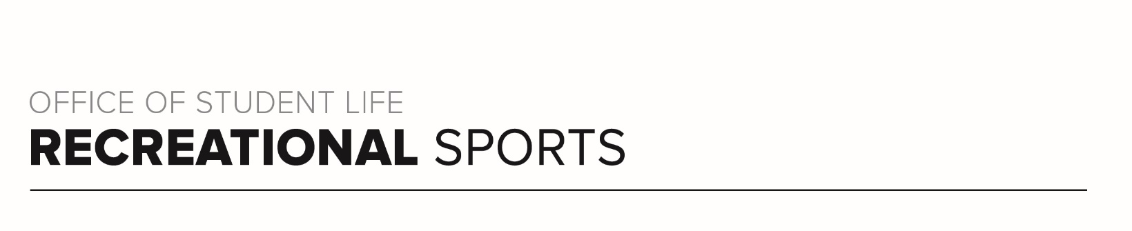
Scarlet Workout (#2)

Workout Focus:
Lower Body
Core

Equipment Needed:
Dumbbells

Warm Up: 5 minutes
3-4-minute walk, jog or bike (or jog in place/jumping jacks)
10 body weight squats
10 body weight step back lunges
10 good mornings
25 jumping jacks

SET 1
Legs: 40-30-20 Round. You will do each exercise for 40 seconds. Repeat for 30 seconds and finally for 20 seconds. Your goal each round is go up in weight or maintain what you start with. In between the time changes, you will do 25 walking lunges (anywhere you have space). Use heavy dumbbells!

40 seconds
Squats
RDL’s
Sumo Squat
*25 Walking Lunges

30 seconds
Squats
RDL’s
Sumo Squat
*25 Walking Lunges

20 seconds
Squats
RDL’s
Sumo Squat
*25 Walking Lunges

Core: Lay on your back. Place hands under glutes for extra support if needed. All rounds 30 seconds. Do a total of 3 rounds.

30 seconds
Scissor Kicks
Alternating Deadbugs
Full Sit Up
Russian Twist
Repeat 2x

SET 2
Legs: This is similar to set 1 however you will work 1 leg at a time and each leg will be completed for 40 seconds and then 30 seconds. 25 glute bridges in between each round for 100 total glute bridges.

40 seconds
Right Leg Lateral Lunge
Right Leg Single Leg Deadlift
Right Leg Step Back Lunge
*25 Glute Bridges

40 seconds
Left Leg Lateral Lunge
Left Leg Single Leg Deadlift
Left Leg Step Back Lunge
*25 Glute Bridges

30 seconds
Right Leg Lateral Lunge
Right Leg Single Leg Deadlift
Right Leg Step Back Lunge
*25 Glute Bridges

30 seconds
Left Leg Lateral Lunge
Left Leg Single Leg Deadlift
Left Leg Step Back Lunge
*25 Glute Bridges

Core: All exercises are in plank position. Rounds are 30 seconds long and should be done for 3 full sets.

30 seconds
Forearm Plank Hold
Plank Hip Dips
Full Plank Hold (on palms)
Slow Mountain Climbers
Repeat 2x

